ITEM PF8E

PENSION FUND COMMITTEE – 28 MAY 2008

OVERVIEW AND OUTLOOK FOR INVESTMENT MARKETS

Report by the Independent Financial Adviser

- Gradually the ripples (or waves) from the ‘credit crunch‘ are extending further and beginning to impact the real economy. The crunch overtly began with sub-prime mortgage lending in the USA, but was in fact a general under pricing of risk in all financial markets. Consensus estimates of economic growth have been reduced over the last three months, but are still probably too high. Estimates of three months ago in brackets.

Real economic growth % | 2007 | 2008 | 2009
UK | 3.1 | (1.9)1.7 | 1.9
USA | 2.2 | (2.1)1.4 | 2.3
EUROZONE | 2.6 | (1.9)1.5 | 1.8
JAPAN | 2.0 | (1.5)1.3 | 1.8

The IMF has recently cut its estimates, substantially for the USA, forecasting growth for 2008 of 0.5%, UK 1.6%, Euro zone 1.4% and Japan 1.4%, but even these, particularly for the UK and Eurozone, could still be too high.

- In the UK mortgage rates have risen because the cost in the wholesale money markets has risen, in spite of official rates having been reduced from 5³/₄% to 5%, as banks and financial institutions have hoarded cash thus reducing liquidity and also been reluctant to lend to other financial institutions for fears of insolvency by the borrowers. This has naturally impacted the availability of funds for mortgages and mortgage approvals in March fell to a level not seen since 1992, when the housing market last fell. This will add to the downward pressure on house prices. See graph below.

Surveyors correctly predicted the price falls of 1980-82 and 1990-1993.

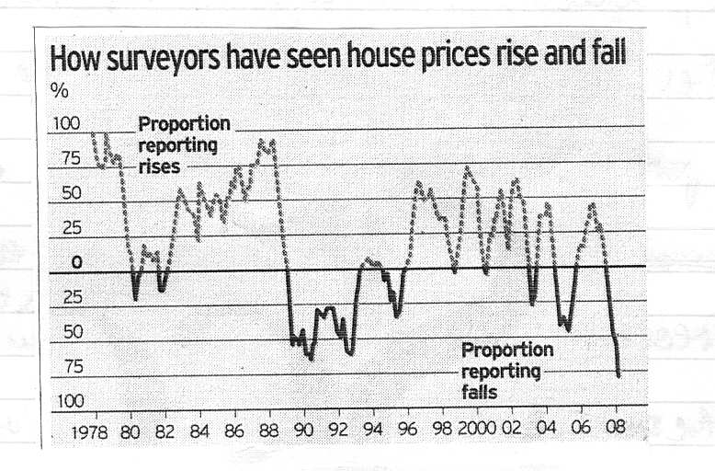
- Further, some 2.75 million borrowers will need to re-finance as their low fixed rate or tracker mortgages come up for renewal and their mortgage payments will increase sharply. Coupled with this food and energy prices have risen strongly. Thus, consumer expenditure is being squeezed and consumer confidence has fallen sharply to a 13 year low. Consumers also have a record level of non-mortgage debt. All this will inevitably cut the growth in consumer expenditure substantially, particularly if people try to reduce debt levels. So far employment has held up, but it is a lagging indicator. However, companies are already beginning to look at cutting costs in reaction to the credit crunch by freezing recruitment and employers taking on more temporary workers in place of permanent, while 45% of medium size companies are looking to reduce staff numbers. Consumer expenditure represents approximately two thirds of GDP. In the UK corporate sector, following strength in both manufacturing production and service sector activity in February, manufacturing fell in March and the service sector was almost at a standstill in April. The lower exchange rate will help exports, but companies generally are reducing capital expenditure.

- In the USA, the FED. (the US central bank) reports that three-quarters of Fed. districts had experienced ‘slowing in the pace of economic activity’ that consumer expenditure was ‘softening’ (see chart below) and demand for residential property was ‘anaemic’. The labour market is contracting with its steepest drop in March since March 2003, although April’s fall was much less, corporate inventories are building up, profitability falling and the index of leading indicators is now signalling a recession, which would support the IMF estimate of very low growth this year, probably with two quarters of negative growth. Further, house prices are now falling sharply (see chart below), new house sales continue to fall and the consumer is over borrowed, all of which does not bode well for consumer expenditure. So far the Eurozone economy has held up, but softening is beginning to appear. The German business climate index has dropped to the lowest level for over two years, French business sentiment has declined sharply and consumer expenditure has actually fallen with consumer confidence at a 21 year low. Italy is virtually in recession and the strong Euro is beginning to hit exports. While in Japan business sentiment has fallen to a four year low and corporate capital spending suffered its largest drop for five years in the final quarter of 2007.

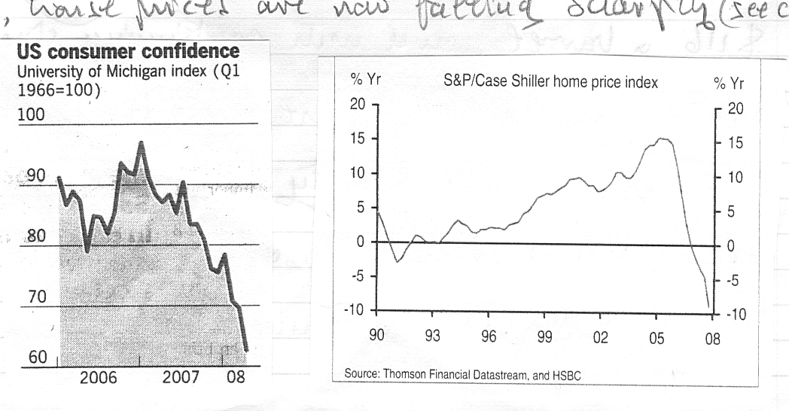

- The picture in the developing world is in sharp contrast. While inevitable they will be affected by slowing growth in developed countries, they are still forecast to continue growing fast, with China achieving 9¹/₂% in 2008 and 2009, India over 7% and the rest of Asia between 4%-6%.
- The crude oil price continues its heady rise, reaching $122 a barrel, and with continuing strong demand it could rise further in the short term. However, with slowing economic activity in the developed world, new refineries coming into operation and inventories rising since the beginning of the year, prices could ease in the next few months in spite of a small cut in production by OPEC and supply disruptions in Nigeria. However in the medium term, with continuing strong demand from developing countries and non-OPEC oil production trending on a plateau, prices could remain very firm. If oil prices were to continue at current record levels this would cut developed countries economic growth further. Base metals remain very firm, with copper and tin at record prices. Food prices are now also rising sharply.

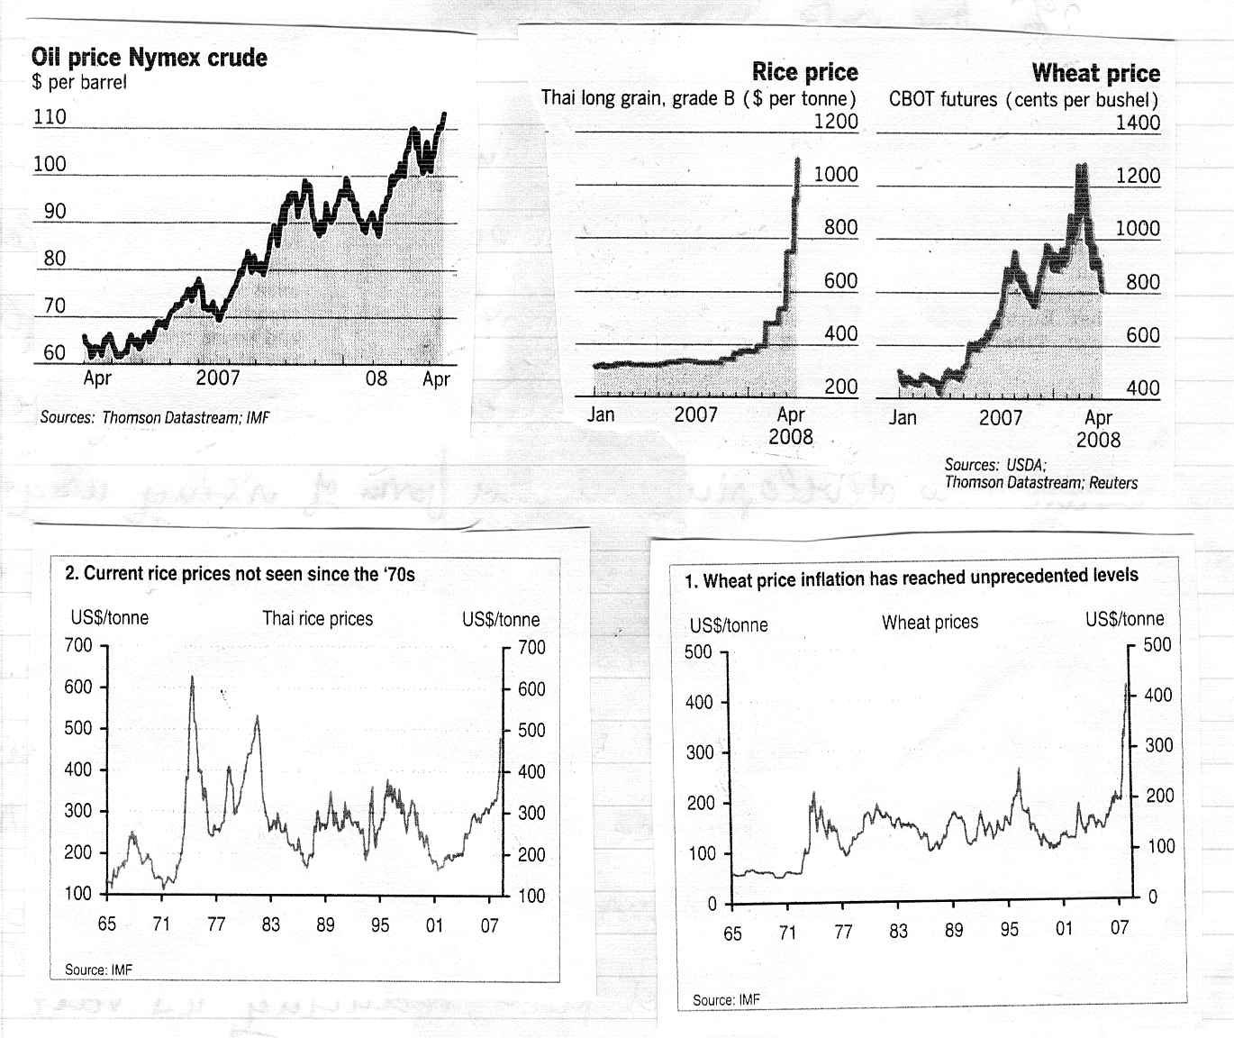

- The commodity price rises are increasing the inflationary pressures in all countries. In the UK the CPI is 2.5% and expected to move higher, while RPI is 3.8%. The story is similar in the USA, while in the Eurozone, which has normally had lower inflation with a target of ‘below but close to 2%’, the rate is now 3.6%.

- Thus, the dilemma continues for central banks. The response to strong inflationary pressures should normally be to lift interest rates, even though part of the inflation is imported but secondary pressures are now developing in the form of rising wage claims. However, the credit crunch is now impacting economic growth, which could moderate inflation in the medium term, and so central banks are or will probably soon reduce interest rates. The Bank of England is adopting a more measured pace, reducing its rate from 5³/₄% to 5% and it could be 4¹/₂% towards the end of the year. The Fed. has reduced rates aggressively from 5¹/₄% to 2%, but it may pause after the last ¼% reduction to see how the economy evolves over the next few months. The European Central Bank is still talking about inflationary pressures, but less aggressively than a short while ago, and it could reduce rates from the present 4% to 3¹/₂% later in the year. However, while market over night rates are close to official rates, three month inter bank rates are still much higher viz UK 5.8% v official 5.0%, USA 2.8% v 2.25% and Eurozone 4.9% v 4.0%. The central banks have been providing massive short term liquidity, but very recently the Bank of England has introduced a scheme to allow banks and other financial institutions to exchange top quality (triple A) mortgage backed securities for highly liquid Treasury Bills, initially for a period of a year, but extendible to three years. It remains to be seen if this will free up the mortgage market and bring three months interbank rates down to closer to official rates. The Bank of England may signal that the worst effects of the credit crunch are over, but that is not yet evident in the money and debt markets and its full impact is yet to be seen in the economy and the equity market.

- Monetary policy needs to be supported by fiscal policy. The US is providing a $170 million tax rebate over two years. Although it is much larger than 2001 rebate, unlike 2001 it is not a permanent reduction and consumers are now much more over borrowed, and so its impact may not be so great. In contrast the UK budgetary position is so tight, with Brussels censuring the country for breaching the 3% of GDP limit on budget deficits under the Stability and Growth pact, that there is no scope for fiscal policy to support monetary policy. The Eurozone is not yet at the point of considering fiscal support.
Markets

- Over recent weeks the government bond market has at different times reflected the prospect of lower economic growth and then the fear of higher inflation. Superimposed on this there has also been the ‘flight to quality’ with investors on occasions moving from other debt to the safety of government securities. The following figures show these influences.

UK Gilts Yields | JUNE  2007 | Low MARCH 2008 | APRIL  2008
10 Year Benchmark | 5.4% | 4.3% | 4.8%
4¹/₄% Treasury 2055 | 4.5% | 4.2% | 4.3%
1¹/₄% Index Linked 2055 | 0.9% | 0.5% | 0.5%

- In June 2007, before the credit crunch, the outlook was for strong economic growth and inflation trending higher. By March this year fears of much lower economic growths and a ‘flight to quality’ were dominant, only to be replaced in April by concerns about higher inflation. Spreads (margin of yield over government bonds) remain at record levels, as shown in the charts below, indicating, as with inter-banks money market rates, that an excessive price is now being put on risk, whereas before the credit crunch risk was under priced. Similarly, the price of credit default swaps (CDS), which insure against loans defaulting is extremely high.

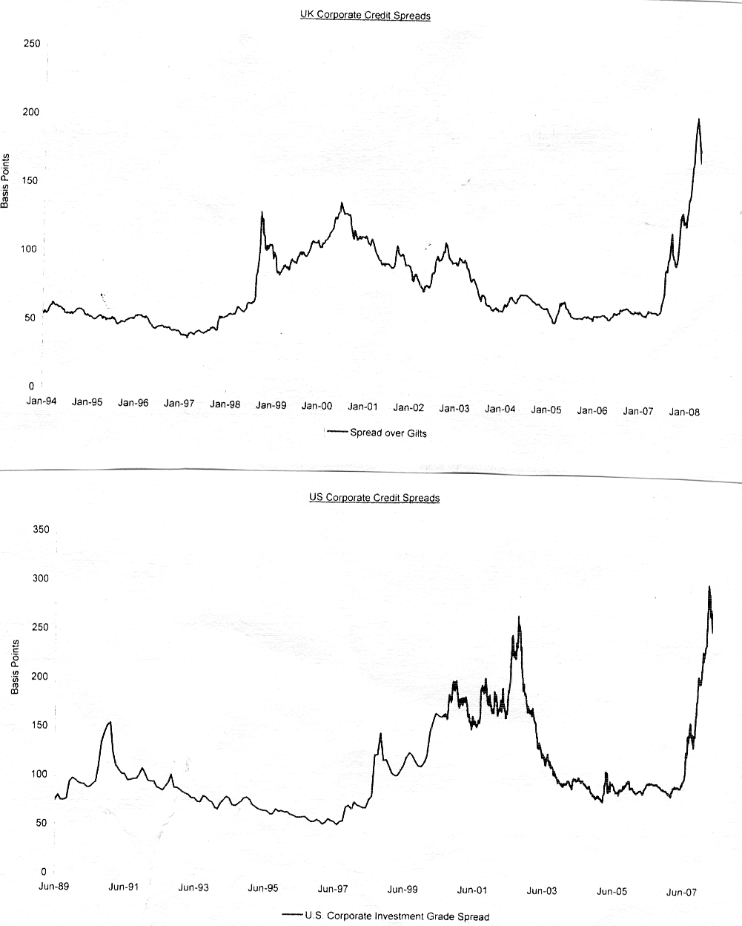

- In contrast in the equity market risk may not yet be fully priced. Economic growth in the developed world is slowing, house prices falling and the consumer retrenching. Corporate profits as a share of GDP were at a record level at the peak of the cycle in 2006-07, but with cost pressures rising this record level is unlikely to be maintained. Further, slower economic growth will eat into margins. Analysts have started to down grade profit estimates from an initial forecast of growth in 2008 to a decline, but if the banking sector is excluded they are still expecting modest profit growth for the rest of the market, which would seem unrealistic. Thus, consensus price/earnings ratios of 12.1x for 2008 and 11.5x for 2009 for the UK market and 10.3x and 9.3x for the Eurozone initially look reasonable, but with further profit downgrades they could quickly look much less reasonable. The US on 17.1x is high and above its 20 year average of 16.4x, which is not a good level as the economy weakens. Further the support of share buys backs by companies, thus shrinking the market float, no longer operates, while, with the sharp rise in corporate bond rates, debt is now expensive and now not the preferred source of finance compared to shares. So there will be a rise in equity funding as is already being seen in the banking sector, thereby dampening enthusiasm for equities.

- Nevertheless, there are some positive technical indicators. The Vix equity market volatility index – the ‘fear gauge’ – fell, following the Bear Stearns rescue, to a level of 12 and is now at 19 compared with a 52 week high of 37. Also, at the end of March short selling (by traders who do not own the shares) was at a very high level, which has provided short term support for the market as they have had to buy to cover, thus helping the market to rise. Nevertheless it is probably just a rally in a bear market and equities could experience a difficult summer. In March it tested the technical support on FTSE100 at 5400 when if fell to 5478 and it could again be tested. If it fails, the next support is around 4800. By the autumn the full impact of the credit crunch should be clearer and the equity market will be looking to 2009, when prospects hopefully will be better and conditions could be propitious for a new bull market.

- Commercial property values are continuing to fall, but the rate of decline is slackening. Average capital values fell from their peak in mid 2007 to end 2007 by around 10%, resulting in a negative total return (capital value and rent) of -3.4% for the year 2007, the first negative outcome since 1991. In the first quarter of 2008 capital values fell by 4.7%, or by 3.4% with the addition of rent. With the fall in capital values yields have risen, but the margin over government bond yields is still only back to the level of 2005 as the chart below shows.

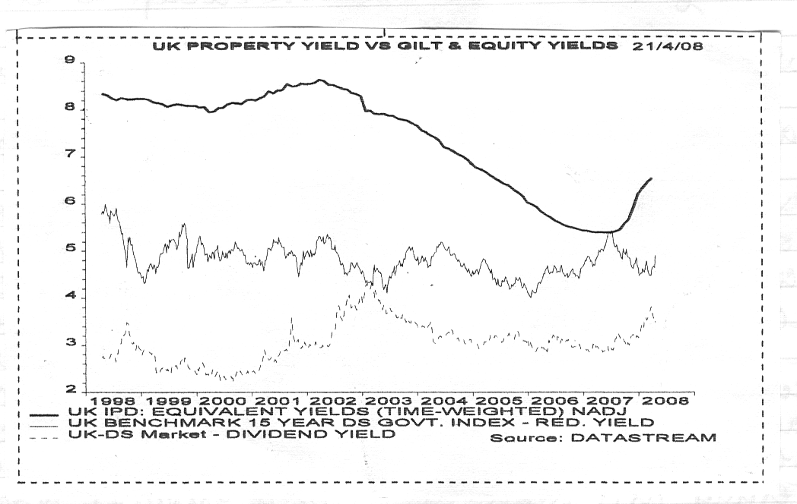
- The outlook for commercial property is difficult. With retail sales weakening and with tough trading conditions in the high street, the demand for retail space has fallen to its lowest level for a decade and several large shopping developments are being postponed. The office market is equally difficult with expected large redundancies in the financial services industry and other companies seeking to limit or cut costs. Further declines in capital values will increase the property yield margin over government bonds.
- The US dollar has been very weak, particularly against the Euro and the Japanese yen. While the US balance of payments deficit is large, it is on an improving trend, with exports being helped by the low currency. Also US assets looks cheap to the foreign investor. The US dollar looks over sold and could stage a recovery over the rest of the year. The position of sterling is not as encouraging even though on the trade weighted effective rate it had fallen 12% from its high in mid 2007, before recovering fractionally recently. With the prospect of further cuts in interest rates, with a weakening economy with no prospect of support of a fiscal package, with its reliance on an embattled financial sector, a record balance of payments deficit of around 4% of GDP and still overvalued on fundamentals, sterling will probably weaken further against the US dollar, towards the $1.85 level in the medium term, and against the yen, but may steady against the Euro, which has risen so fast.

A. F. BUSHELL

Independent Financial Adviser

May 2008

